
RAMAIAH
Institute of Technology
USN | 1 | M | S

(Autonomous Institute, Affiliated to VTU)
(Approved by AICTE, New Delhi & Govt. of Karnataka) Accredited by NBA & NAAC with ‘A’ Grade

SEMESTER END EXAMINATIONS – JANUARY 2019
Course & Branch | : | B.E. : Common to all branches | Semester | : | I
Subject | : | Basic Civil Engineering and Mechanics | Max. Marks | : | 100
Subject Code | : | CV14 | Duration | : | 3 Hrs

Instructions to the Candidates:
- Answer one full question from each unit.
- Any data missing can be assumed suitably.

 |  | UNIT-I
1. | a) | Explain briefly about the following fields of civil engineering.  - Hydraulics and water Resource Engineering  - Geotechnical Engineering  - Environmental Engineering | CO1 | (10)
 | b) | Explain the components of Gravity dam and earthern dam with a neat sketch. | CO1 | (10)
2. | a) | Explain the impact of infrastructural development on the economy and environment of a country. | CO1 | (10)
 | b) | Briefly explain the properties and applications of RCC and steel. | CO1 | (10)
 |  | UNIT-II
3. | a) | State and prove Varignon’s principle of moments. | CO2 | (10)
 | b) | Determine the magnitude, direction of the resultant force for the system shown in Fig.3(b). Locate the resultant force w.r.t point D.  Fig.3(b) | CO2 | (10)
4. | a) | Explain with an example.  - Principle of transmissibility of forces  - Resolution of forces  - Equilibrant of a system of forces | CO2 | (10)
 | b) | Determine the resultant force acting on the structure at point O both in magnitude and direction.  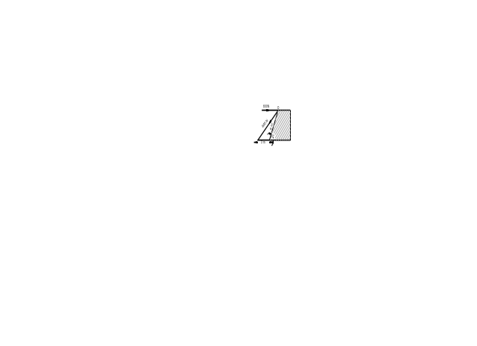  Fig.4(b) | CO2 | (10)
 |  | UNIT-III
5. | a) | Explain various types of supports with sketches. | CO3 | (06)
 | b) | Fig.5(b) shows an arrangement to which the weights 440 N and 560 N are suspended. The pulley are frictionless. Find the tension in the string BC, reaction at E, and inclination of string DB at D for the equilibrium condition.  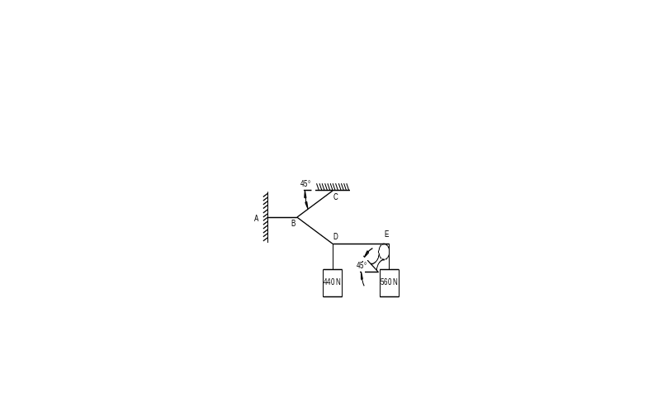  Fig.5(b) | CO3 | (14)
6. | a) | Differentiate between statically determinate and indeterminate structure with example. | CO3 | (06)
 | b) | Determine the reactions at support for the beam shown in Fig 6(b).  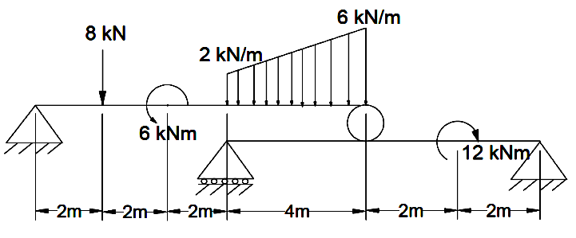  Fig 6(b) | CO3 | (14)
 |  | UNIT-IV
7. | a) | Define the following terms (ii) polar moment of inertia (iii) Radius of gyration | CO4 | (04)
 | b) | State and prove parallel axis theorem. | CO4 | (06)
 | c) | Find the centroid of the shaded area shown in Fig.7(b)  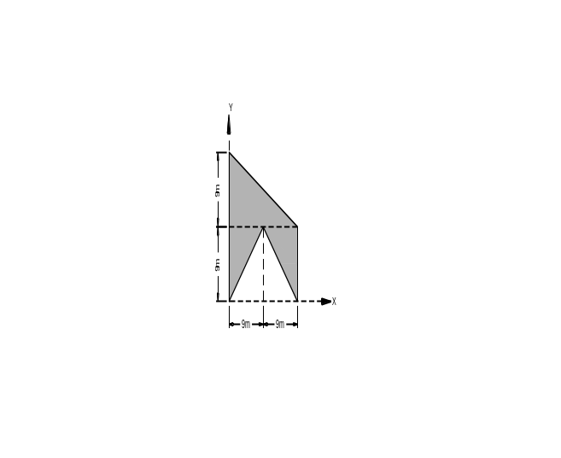  Fig.7(b) | CO4 | (10)
8. | a) | Derive the equation to determine the centroid of a semi-circular area from first principles | CO4 | (10)
 | b) | Determine the moment of inertia and radii of gyration of the area shown in Fig.8(c) about the base AB and the centroidal axis parallel to AB.  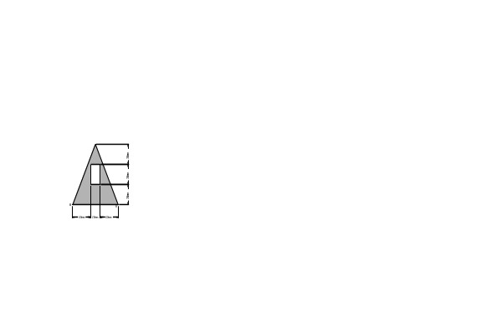  Fig.8(c) | CO4 | (10)
 |  | UNIT-V
9. | a) | Show that angle of friction is equal to the angle of repose for any two surfaces in contact. | CO5 | (04)
 | b) | Derive the equation to the path of the projectile | CO5 | (06)
 | c) | A body is projected at an angle of 30° to the horizontal with a velocity of 100m/sec. Find the maximum height attained the horizontal range and the time of flight, take g=9.8m/sec². | CO5 | (10)
10. | a) | Determine the range of values which the weight ‘W’ may have so that the block of mass 100kg shown in Fig.10(a) will neither start moving up the plane nor slip down the plane. Take µ = 0.3. Assume smooth pulley.    Fig.10(a) | CO5 | (10)
 | b) | Two objects A and B are projected vertically at 130m above the ground level. A is projected up with a velocity of 30m/sec and ‘B’ is projected downwards with the same velocity. Find the time taken by each object to reach the ground. Also find the height from which the object ‘A’ must be just released from rest in order the two objects hit the ground simultaneously. | CO5 | (10)

****************

